**Universal Print printer provisioning tool**

**Overview**

Universal Print printer provisioning tool helps organizations deploy printers on users' Windows 10 devices using Microsoft Endpoint Manager.

In this document, we cover requirements, configurations and steps to use this tool.

**Pre-requisites**

Before using the tool, please ensure that the following steps have been completed:

1. Meet the requirements as per [Get Started documentation](https://docs.microsoft.com/en-us/universal-print/fundamentals/universal-print-getting-started).
2. Windows 10 devices need to have the latest Windows Update installed:
   1. Windows 10, version 2004: [KB4571744](https://support.microsoft.com/help/4571744/windows-10-update-kb4571744)
   2. For Windows 10, versions 1903 and 1909: [KB4566116](https://support.microsoft.com/help/4566116/windows-10-update-kb4566116)
3. Windows 10 devices are enrolled with Microsoft Endpoint Manager

**Setting-up:**

**Step 1: Download the Universal Print printer provisioning tool**

Download all the files for Universal Print printer provisioning tool from [Microsoft Download Center](https://aka.ms/UPIntuneTool_DL).

The download contains following files:

1. UniversalPrintPrinterProvisioning.0.1.0.0.intunewin: This is a pre-packaged Intune Win32 app package that contains the printer provisioning tool. Using Microsoft Endpoint Manager this package needs to be deployed on all the devices where Universal Print printers need to be pre-provisioned.
2. SamplePolicy.zip: This ZIP folder contains two files:
   1. printers.csv (sample): This file is an example. It may be used as a reference to create a list of printers that need to be added on the given set of users' devices.
   2. InstallPolicy.cmd is a simple script that copies the printers.csv config file to the appropriate folder on users' devices.
3. EULA.rtf: The tool is under preview. Your use of the software operates as consent to the terms of the End User License Agreement (EULA), which is included with the tool in the file named “EULA.rtf”.

**Step 2: Deploying the Intune Win32 app package**

Using [Microsoft Endpoint Manager](https://endpoint.microsoft.com/) deploy UniversalPrintPrinterProvisioning0.1.0.0.intunewin as a Windows app (Win32) on all the target devices where printers need to be pre-provisioned.

While deploying the package, most of the fields will be pre-populated. (like *Install Behavior* as *System*). Other fields should be populated as:

1. Under *Requirements*:
   1. *Operating System Architecture*: Select both *32-bit* and *64-bit*.
   2. *Minimum Operating System*: *Windows 10 1903* (minimum requirement for Universal Print)
2. Under *Detection Rules*,
   1. Select *Rules format* as *Manually configure detection rules* and click on *Add*
   2. Select *Rule type* as *MSI*. Corresponding fields will be auto populated.
3. Under *Assignments*, add the device groups that contain Windows 10 devices where printers need to be pre-provisioned.

For details on how to deploy Intune application package, refer to [Intune Standalone – Win32 app management: Add a Win32 app to Intune](https://docs.microsoft.com/en-us/mem/intune/apps/apps-win32-app-management#add-a-win32-app-to-intune).

**Step 3: Create the list of printers printers.csv that need to be deployed on users' devices**

Create a config CSV file with the list of printers. Name the CSV file as "printers.csv".

If you need to deploy different printers for different set of users, then you will need to create one printers.csv config file per user group.

Printers.csv file should contain:

1. Header row with three column names: SharedID, SharedName, IsDefault
2. Have one printer per row. Printer's SharedID, SharedName can be retrieved from Universal Print portal (see below image) or PowerShell.

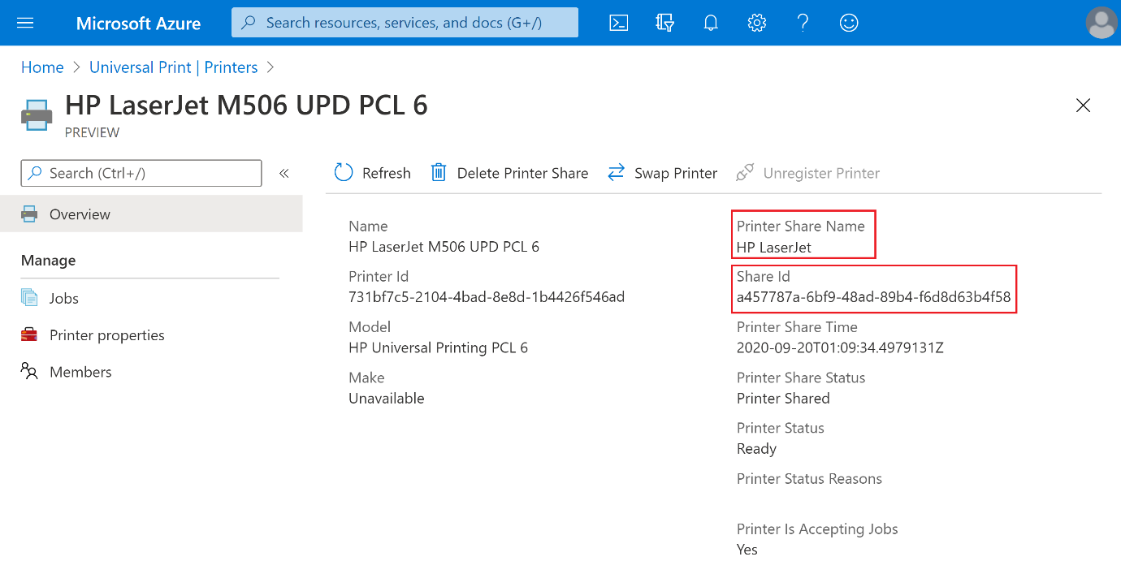

**Note**

For reference, look at printers.csv sample downloaded as part of the package (SamplePolicy\printers.csv).

**Step 4: Generate the custom Win32 application package (*Intunewin* file) to deploy printers.csv**

Using the [Microsoft Win32 Content Prep Tool](https://go.microsoft.com/fwlink/?linkid=2065730) create a custom Win32 application package (we will name it InstallPolicy.intunewin - you can use your own name). This custom application package will be used to deploy printers.csv file on users' devices.

[Intune Standalone - Win32 app management: Prepare the Win32 app content for upload](https://docs.microsoft.com/en-us/mem/intune/apps/apps-win32-app-management#prepare-the-win32-app-content-for-upload)

Lets walk through each of the steps in detail:

1. Universal Print printer provisioning tool download contains a command script"SamplePolicy/InstallPolicy.cmd" - This script can be used (as-is) to copy the printers.csv file on user's device.
2. Place the following files in a single folder:
   * Printers.csv created in Step 3.
   * Command script (InstallPolicy.cmd) that was part of Universal Print printer provisioning tool download.

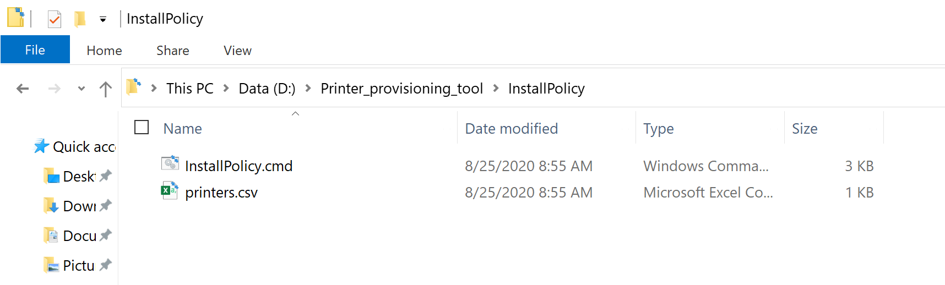

1. Download the [Microsoft Win32 Content Prep Tool](https://go.microsoft.com/fwlink/?linkid=2065730) from GitHub as a zip file. This will download the Microsoft-Win32-Content-Prep-Tool-master.zip file to Downloads folder on your device.

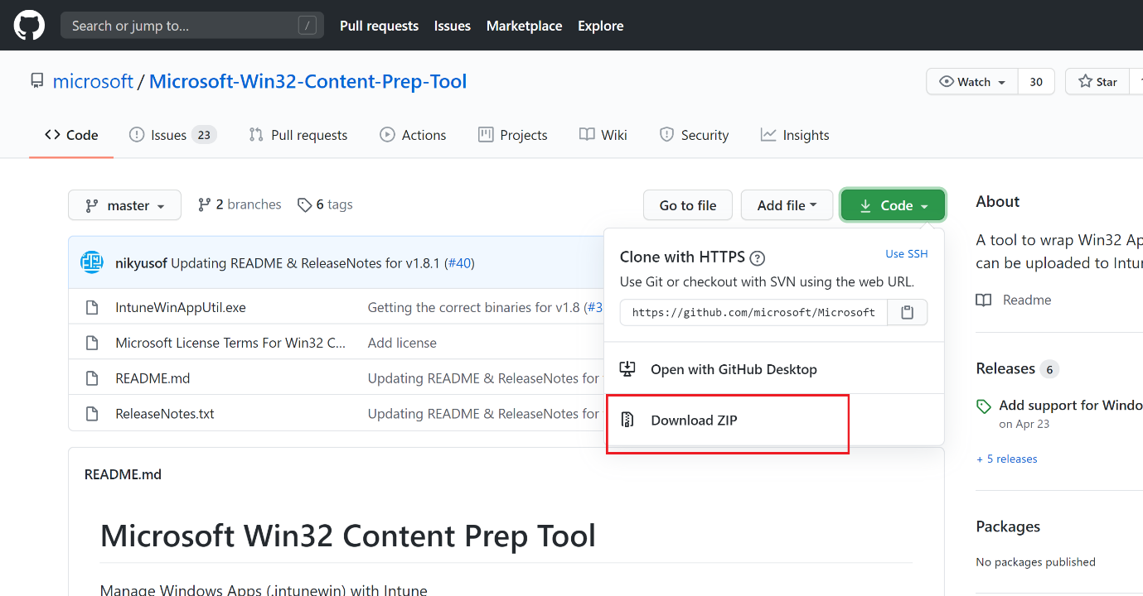

1. Unzip the contents of the Microsoft-Win32-Content-Prep-Tool-master.zip file.

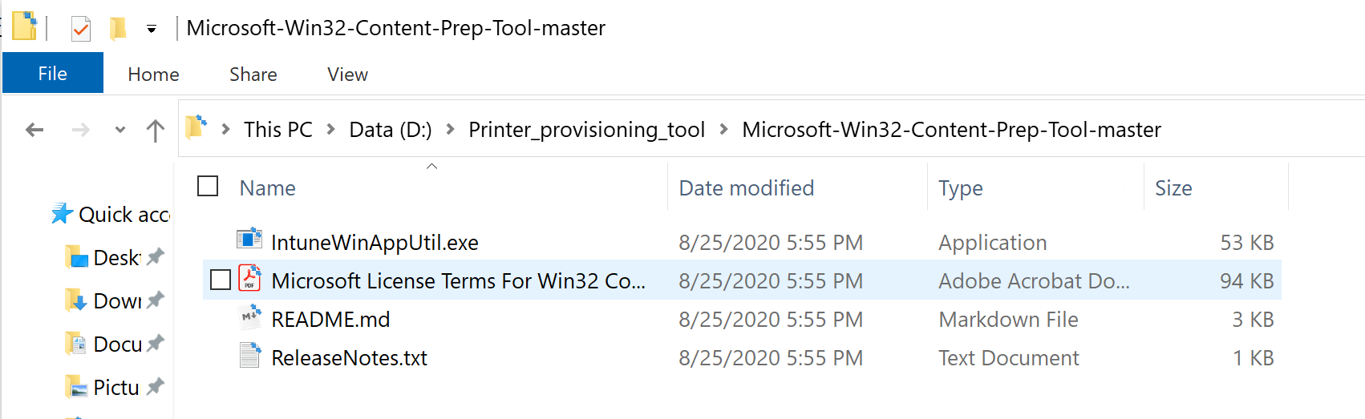

1. Launch Command Prompt and go to the folder where Microsoft Win32 Content Prep Tool files were unzipped.

Run the IntuneWinAppUtil.exe command. When prompted, enter:

* + Source folder: The folder where list of printers (printers.csv) and InstallPolicy.cmd files are present.
  + Setup file: Path of the InstallPolicy.cmd file (or any other script that will be used to copy the printers.csv file on users' devices)
  + Output Folder: Folder where you will like the generated *intunewin* package file to be stored.
  + Do you want to specify catalog folder (Y/N): Enter N.

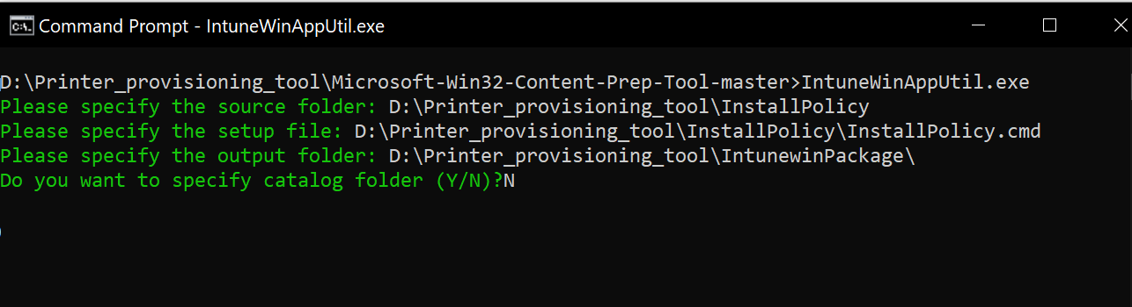

Once all the inputs are entered and you hit enter, tool will generate the *intunewin* package and show the following output:

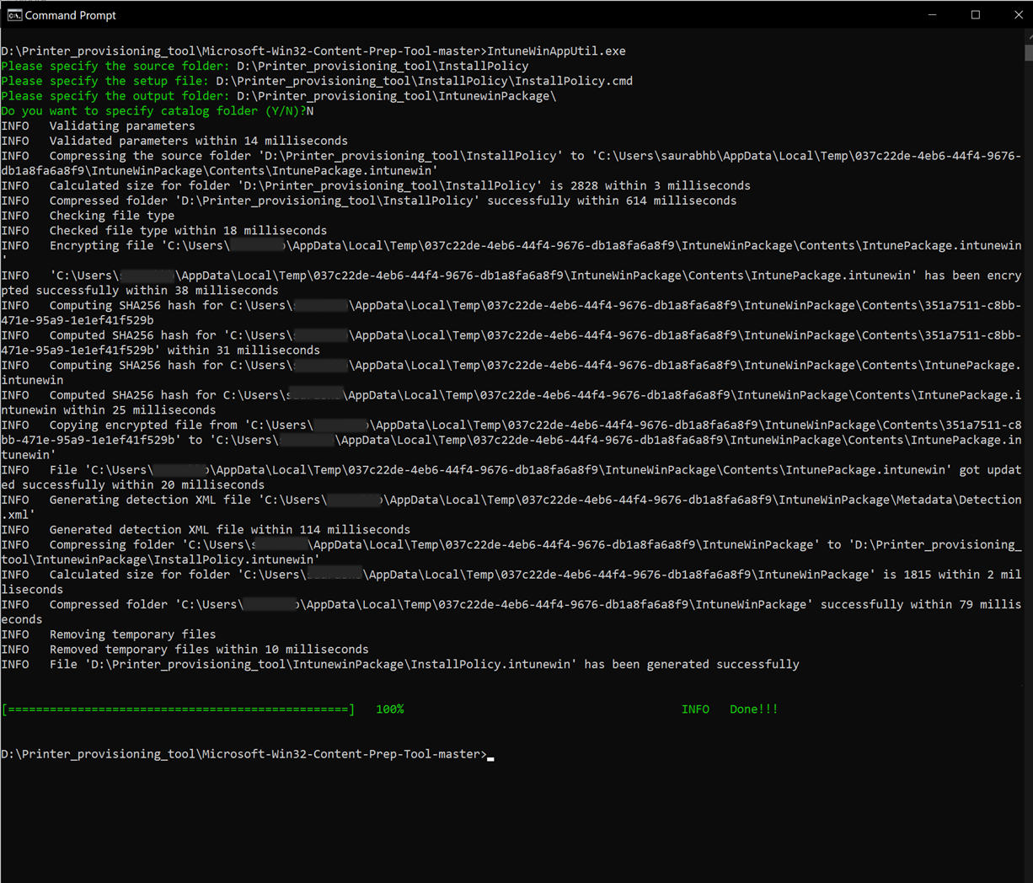

1. The custom *intunewin* package InstallPolicy.intunewin is now generated and can be found in the output folder.

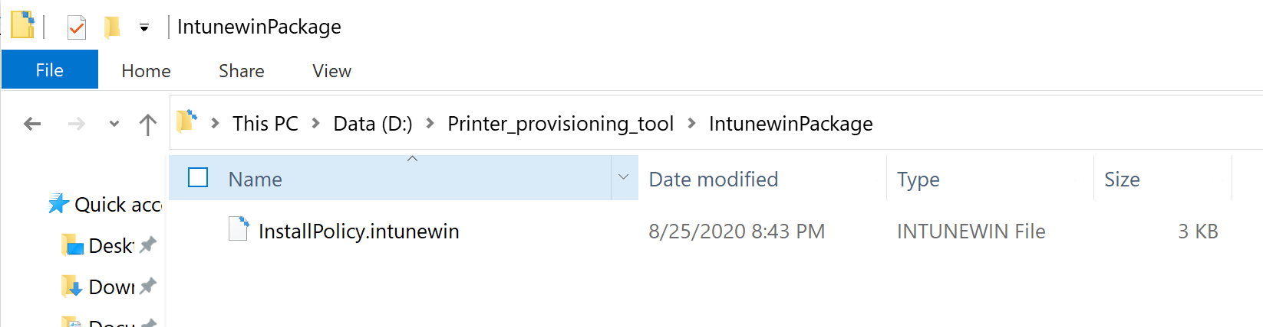

**Step 5: Deploy the custom *intunewin* application package on users' devices**

InstallPolicy.intunewin Win32 application package needs to be deployed on users' devices using Microsoft Endpoint Manager. Here are the steps:

1. Launch [Microsoft Endpoint Manager](https://endpoint.microsoft.com/) and go to *Apps->All Apps*.
2. Click on Add

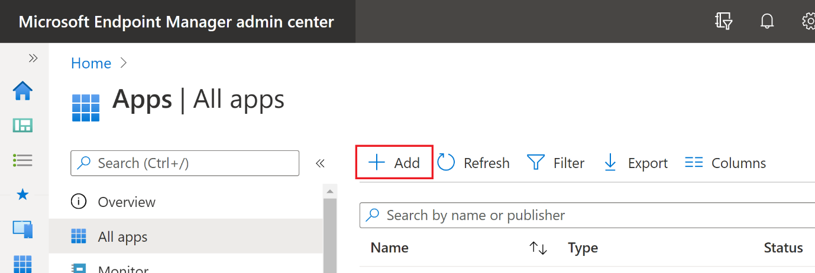

1. Select app type as *Windows app (Win 32)*

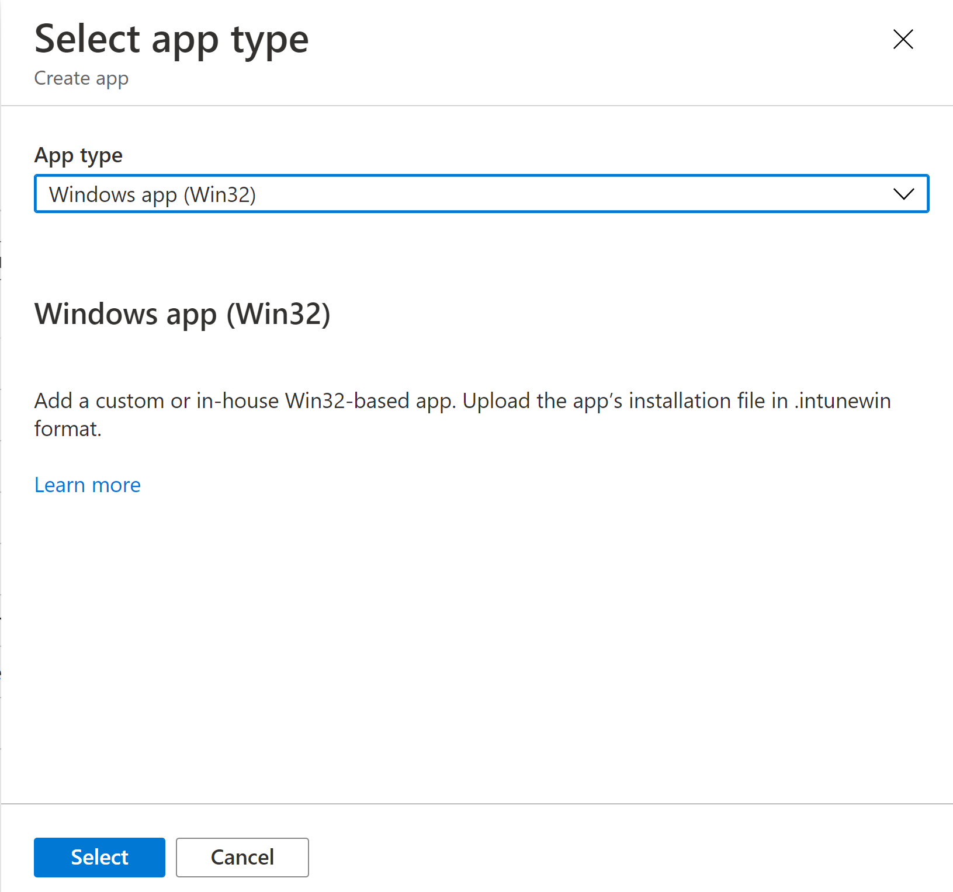

Clicking on *Select* will launch a wizard.

1. *App information* - Select the custom *intunewin* application package (InstallPolicy.intunewin) generated earlier and complete the other App information.
2. *Program* - Printers can be deployed either at a user level (all devices of user) or device level only.

If deploying at *user* level,

* + Under *Install command* enter *InstallPolicy.cmd user install*
  + Under *Uninstall command* enter *InstallPolicy.cmd user uninstall*
  + Under *Install behavior*, select *User*
  + For *return codes*, just keep the code type *success*. Rest of the return codes can be deleted.

This will copy the printers.csv file to *%AppData%\UniversalPrintPrinterProvisioning\Configuration* on users' devices.

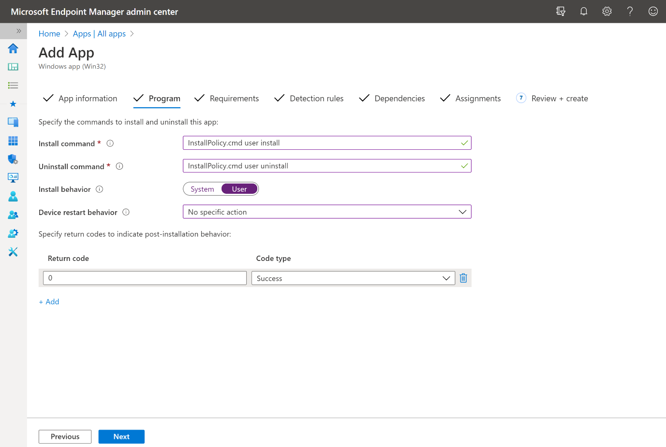

If deploying at *device* level,

* + Under *Install command* enter *InstallPolicy.cmd device install*
  + Under *Uninstall command* enter *InstallPolicy.cmd device uninstall*
  + Under *Install behavior*, select *System*

This will copy the printers.csv file to either of the following folders depending on the device's architecture:

* + On x64 device: "%ProgramFiles(x86)%\UniversalPrintPrinterProvisioning\Configuration\"
  + On x86 device: "%ProgramFiles%\UniversalPrintPrinterProvisioning\Configuration\"

For the rest of this document, we will proceed with context as *user*. There may be a few changes required in the steps below if you want to deploy at *device* level.

For *Device restart behavior* select *No specific action*.

1. *Requirements* -
   * *Operating system architecture*: Select both *32-bit* and *64-bit*.
   * *Minimum operating system*: Select *Windows 10 1903* (minimum requirement for Universal Print)

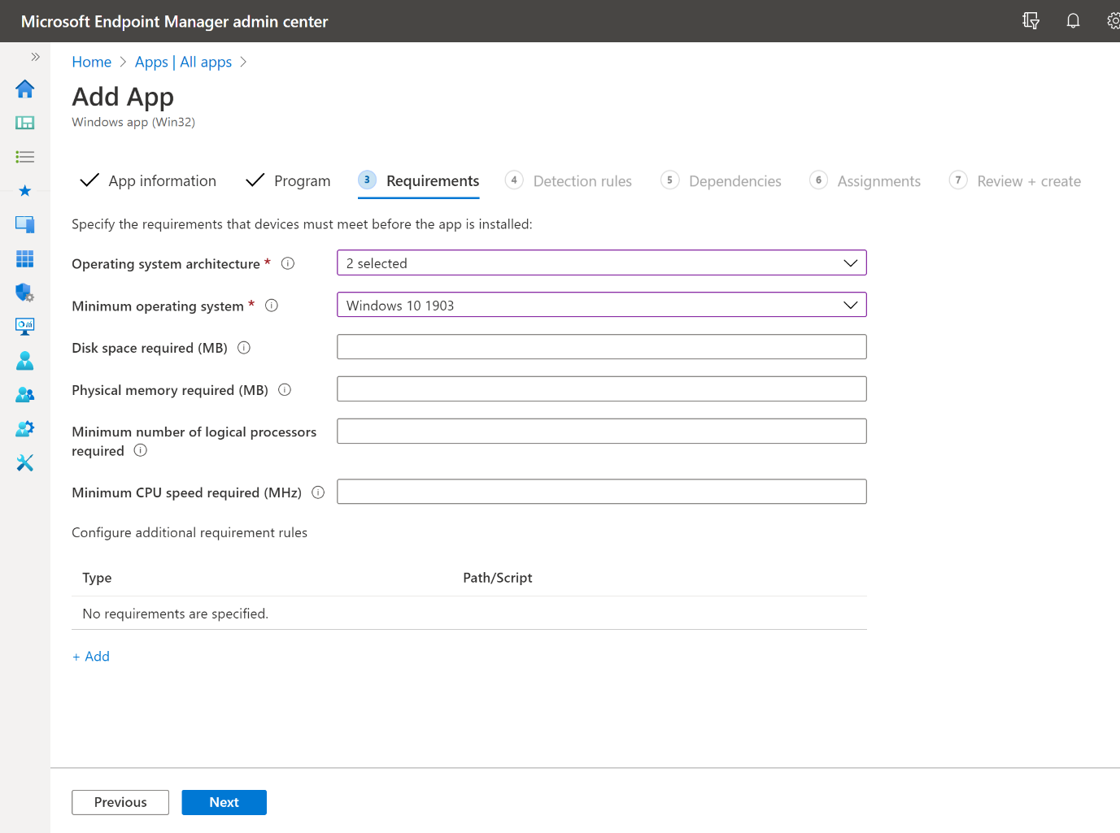

1. *Detection rules* -
   * *Rules format*: Select *Manually configure detection rules*
   * Click on *Add*
     + *Rule type*: Select *File*
     + *Path*: Enter *%AppData%\UniversalPrintPrinterProvisioning\Configuration*
     + *File or folder*: Enter *printers.csv*
     + *Detection Method*: Select *File or folder exists*

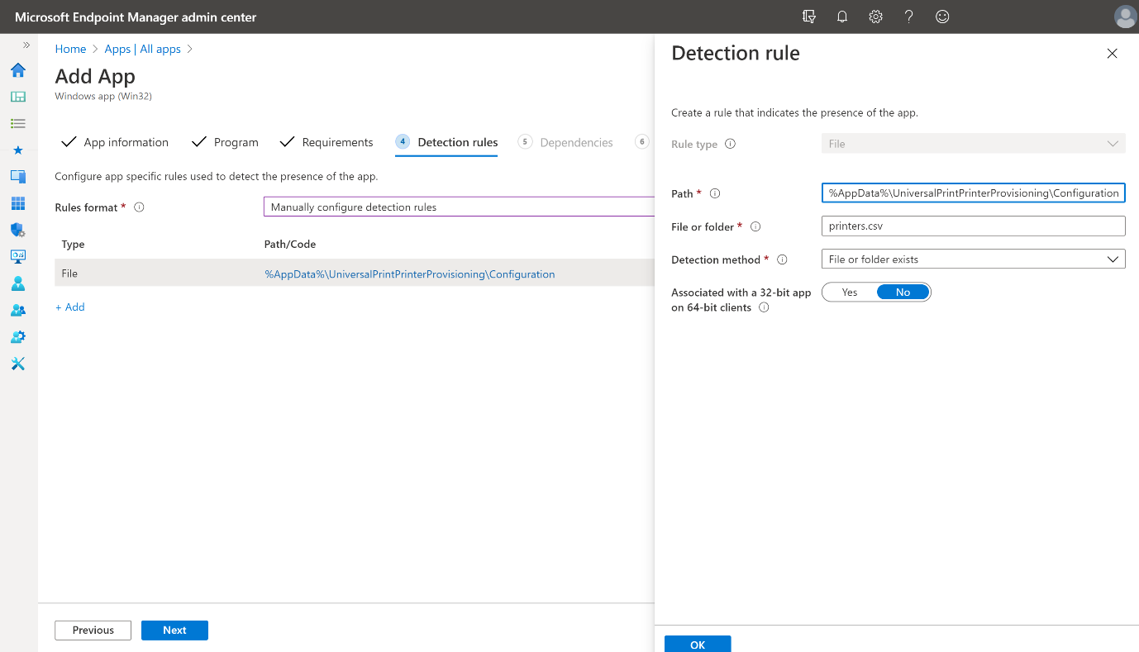

1. *Dependencies* - You can ignore this step and click on *Next*.
2. *Assignments* - Under *Required*, click on *+Add group*. Select the user groups to which the given list of printers in printers.csv needs to be deployed.

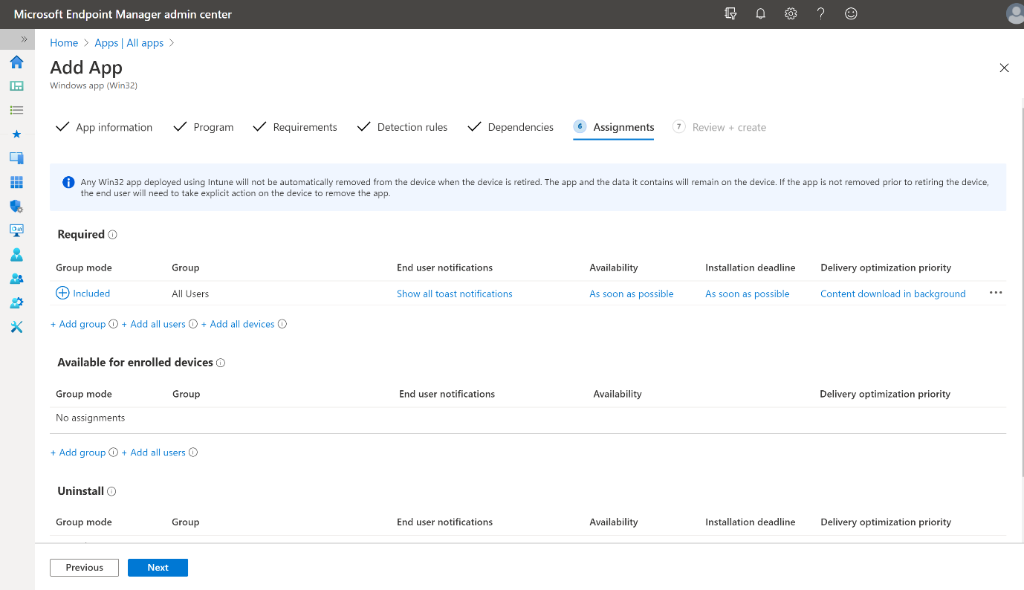

1. *Review+create* - Review all the settings and click on *Create*

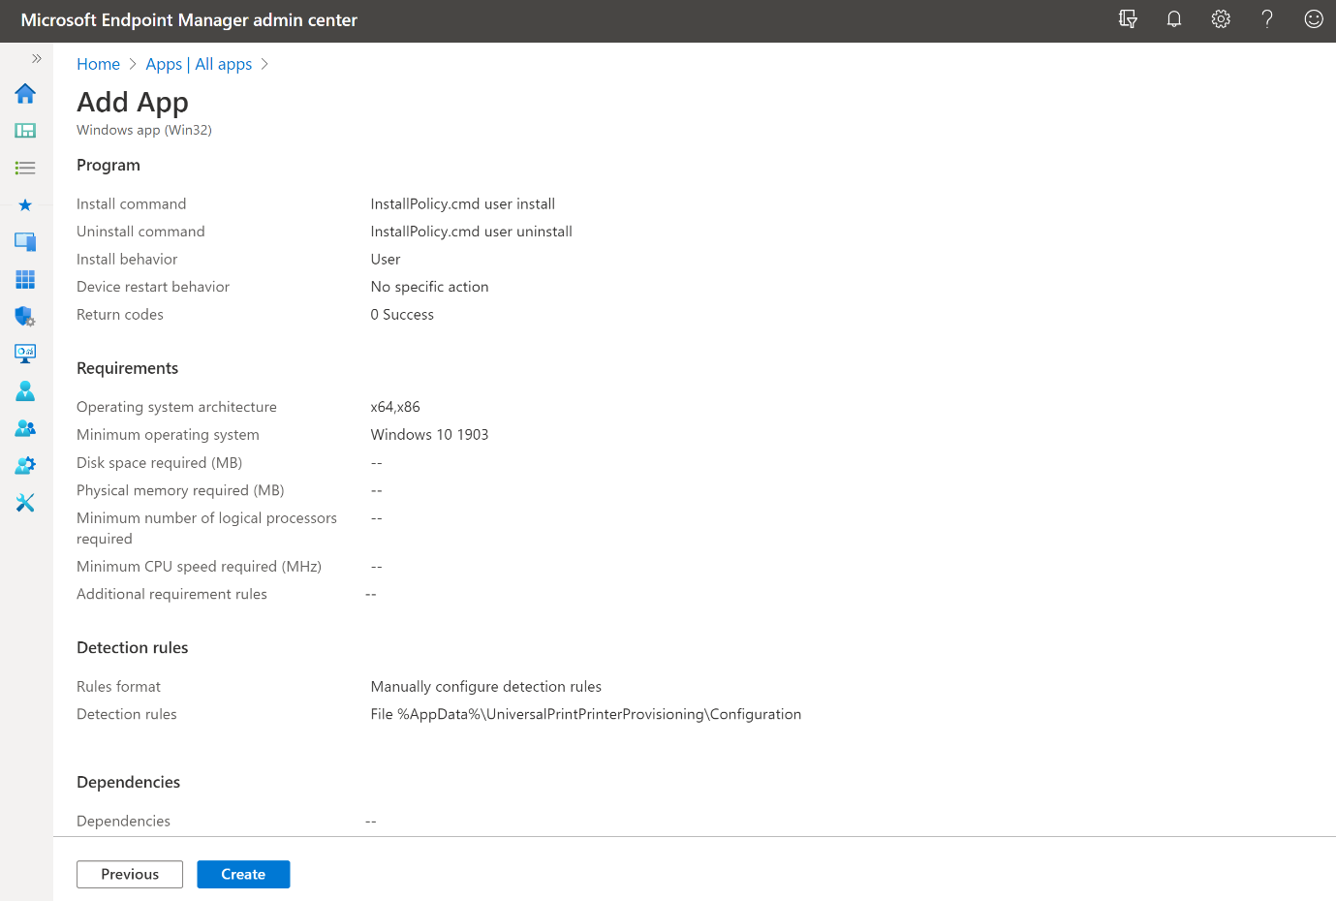

Once all the steps are complete Microsoft Endpoint Manager is ready to deploy your Universal Print printers to the target users' devices.

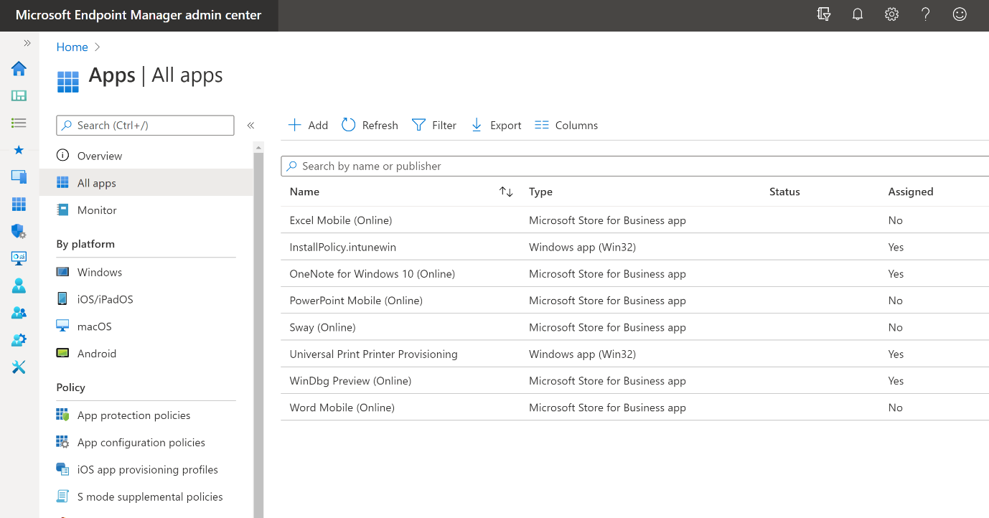

You can click on the corresponding *intunewin* *app* in Microsoft Endpoint Manager and check its *device install status* and *user install status*.

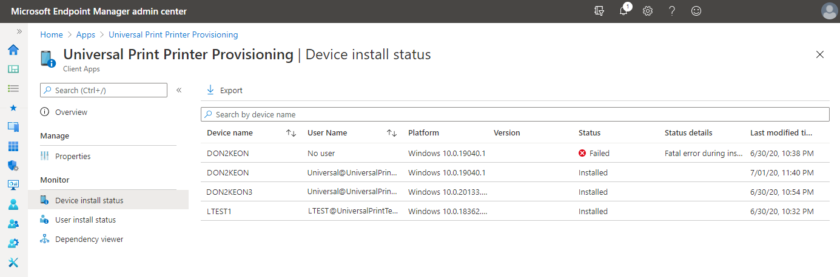

[Monitor app information and assignments with Microsoft Intune](https://docs.microsoft.com/en-us/mem/intune/apps/apps-monitor)

**How are printers installed?**

***Step 2*** above will install a background service on the Windows 10 device. Background service will listen for the *"user logon"* event. Second package (InstallPolicy.intunewin) deployed in ***Step 5*** will put the config file with list of printers on users' Windows 10 device.

When a user logs in, background service will be triggered to install Universal Print printers. It will look for the printers.csv file. If found, then the service will add all the printers listed in the printers.csv file to the Windows 10 device.

**Note**

Only printers that logged-in user has access to will be added to their device.>

**Troubleshooting**

If the Universal Print printers are not installed after the user logs in, check the following:

Confirm that the printers.csv file is present based on the deployment level:

* User:
  + %AppData%\UniversalPrintPrinterProvisioning\Configuration
* Device:
  + On x64 device: "%ProgramFiles(x86)%\UniversalPrintPrinterProvisioning\Configuration"
  + On x86 device: "%ProgramFiles%\UniversalPrintPrinterProvisioning\Configuration"

If the printer defined in the printers.csv file does not install, check the PrintProvisioning event log located on the client under Applications and Services log -> Microsoft -> UniversalPrint for an Event 3 with the following text:

Description: "The system cannot find the path specified."

If you see this error, there are two possible causes.

1. The user does not have access to the printer.
   * Check the Access list for the printer in the Universal Print portal and confirm the user's account is added either directly or as part of an AAD security group.
   * Confirm that you can manually discover and add the printer using "Add printer". If you are unable to manually add the printer, follow the troubleshooting steps under "Installing or discovering printers on client".
2. The printers.csv file has the PrinterID instead of the ShareID.
   * Confirm that the correct ID is being used in the printers.csv file.